Amazon Neptune at GeoSemantics Symposium
July 15, 2019

Presenters
Brad Bebee, Leader of Prod. & Engineering, Amazon Neptune
Kunal Sengupta, Software Development Engineer, Amazon Neptune
Justin Thomas, Sr. Business Development Manager, Amazon Neptune

Agenda:
- Overview of Amazon Neptune as Graph database service
- Introduction to the Resource Description Framework (RDF)
- Migrating Data to Neptune
  - Data transformation
  - Ideas for Migration
- Demo
  - Loading Data into Neptune – using the AirRoutes dataset
  - Executing SPARQL queries in Neptune on the loaded dataset
  - Enrich the data by interlinking AirRoutes data with airport data from Wikidata
  - Showcase integrated SPARQL queries to get the enriched results
  - Running machine learning (ML) algorithms on RDF data

Details:
The presentation is going to be a guided demo that will show various aspects of querying and using Amazon Neptune. Amazon SageMaker’s Jupyter notebook will be used to run this demo, along with a Neptune database instance.

Although this will be a guided demo, interested attendees can follow the below instructions to prepare for a hands-on experience during and after the presentation. Note, it is important to note that running this demo will incur costs for running a Neptune Database instance [1] and running a Jupyter notebook instance [2]. As a managed service, you pay for your database by the hour with no long-term commitments or upfront fees

As a pre-requisite for setting up the hands-on demo, a registered AWS account is required. Attendees who are interested in following the examples hands on during the session are recommended to follow the setup instructions below in advance.

Setting up the Hands-On Stack
Figure 1, shows the overall architecture of the stack used for the hands-on exercises. The stack will be explained during the demo. The creation of the stack is automated using cloud formation scripts. The Steps outlined below can be followed to set up the stack using 2-3 button clicks. Note the demo will set up resources in us-west-2 (Oregon) region only.
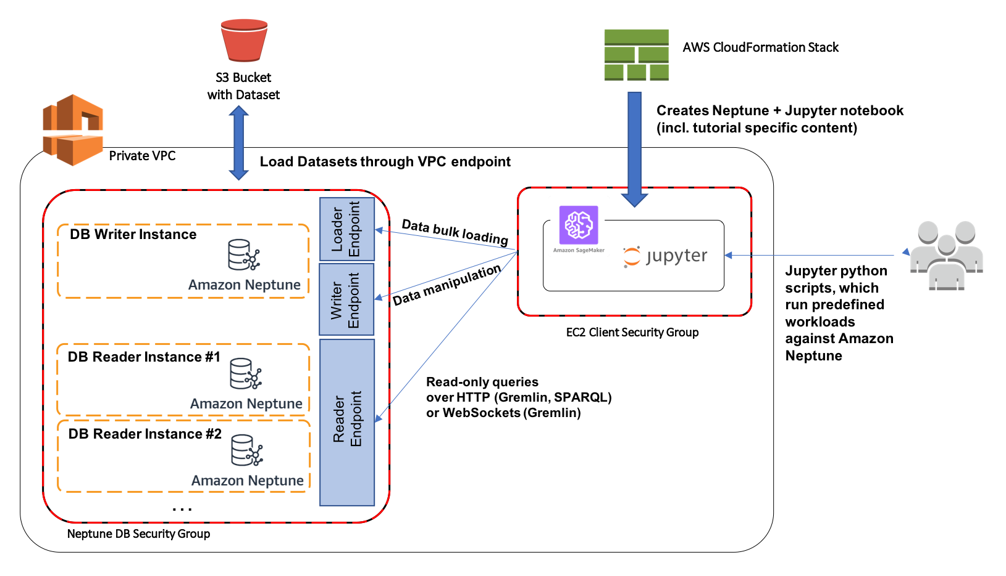
Figure 1 Description of the hands-on stack.
Step 1:
Login to you AWS Account and click on this link to launch the cloud formation stack creation page.

Step 2:
Check the acknowledgement boxes and click on the create button.
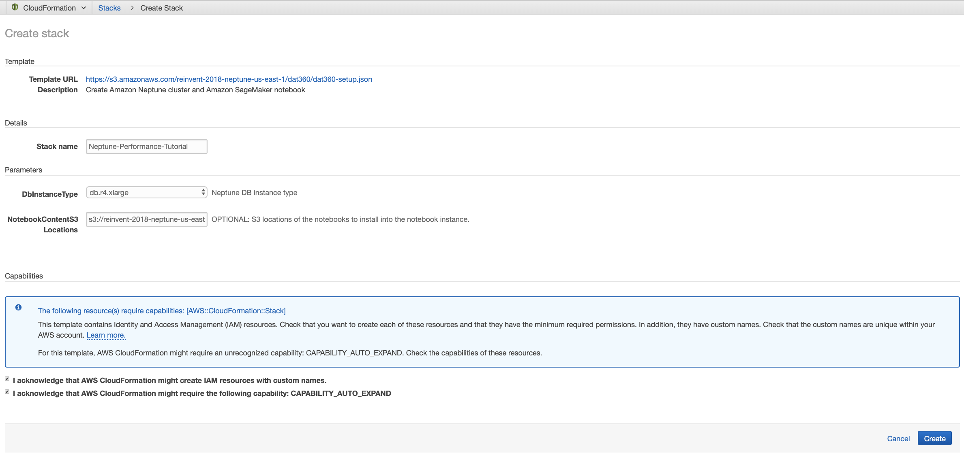
Figure 2 Check the acknowledgement boxes and create

Step 3:
Wait for the cloud formation stack to complete creation of resources. Note, this may take up to 30 minutes to complete.

Once completed successfully, you will find a ready-to-use notebook instance in Amazon SageMaker. You are now ready to follow the demo along with the presenter!

Important note: Since, you will be using AWS resources to run the demo, it will incur usage costs. Please make sure to delete the cloud formation stacks after the demo.

[1] https://aws.amazon.com/neptune/pricing/
[2] https://aws.amazon.com/sagemaker/pricing/
[3] https://docs.aws.amazon.com/AWSCloudFormation/latest/UserGuide/cfn-console-delete-stack.html

Further reading and resources
- Reference Architectures for Graph Databases on AWS: https://github.com/aws-samples/aws-dbs-refarch-graph
- Developer resources (including blogs, github code samples, etc.) - https://aws.amazon.com/neptune/developer-resources/
- Neptune SPARQL query hints - https://docs.aws.amazon.com/neptune/latest/userguide/sparql-query-hints.html
- Neptune SPARQL explain feature - https://docs.aws.amazon.com/neptune/latest/userguide/sparql-explain.html
- Best Practices - https://docs.aws.amazon.com/neptune/latest/userguide/best-practices-sparql.html
- Amazon Neptune Forums: https://forums.aws.amazon.com/forum.jspa?forumID=253

